**JAT Task 12  
JDBC CONNECTIVITY**

**1 – A Question**

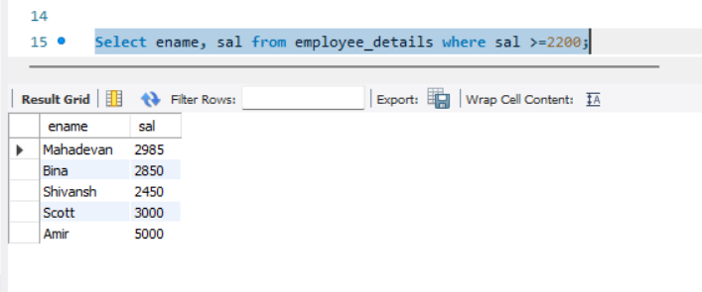

**1 – B Question**

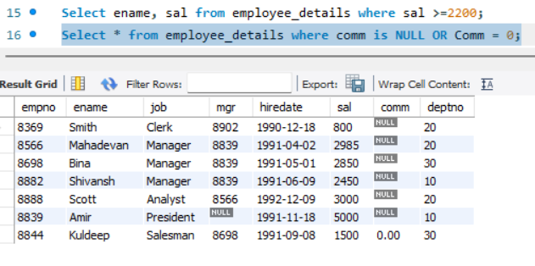

**1 – C Question**



**1 – D Question**

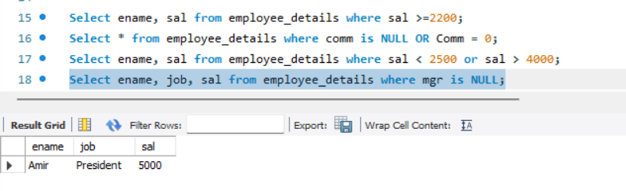

**1 – E Question**

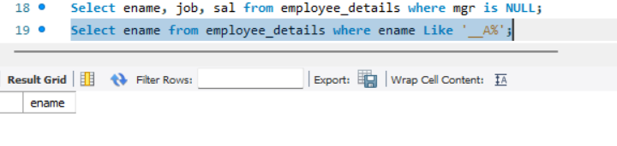

**1 – F Question**

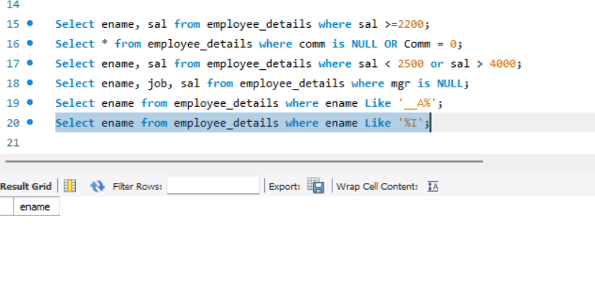

**Question No 2:**

Adding data’s using eclipse by JDBC

Code is in JAT TASK12 in GitHub

